About

The Electronics Club comprises of enthusiastic and innovative minds who aims to find their full potential. We aim to provide students with a platform and resources to gain practical skills. We believe in coming up with projects that can help tackle real-life problems. The mission of the club is to expose students to challenges and new technologies in the field of electronics and thus to nurture and develop their skill set in this arena. The emphasis is on experimenting and learning, no experience is necessary but eagerness to learn is a must.

What We Do

* We help students to acquire and develop new skill-sets by conducting various lectures and workshops.
* We motivate and guide them to come up with innovative projects that tackle real-life problems.
* We provide resources and the technical know-how to realize and shape their projects.
* Through regular meetings and sessions we improve students’ technical and leadership skills.

CLUB ACTIVITIES

|  |  |
| --- | --- |
| PROJECTS  We aim to learn starting from very small  projects as 2-bit adder to making a defence  bot as Iron Man. We do lot of interesting  projects through-out the year | WORKSHOPS  Electronics Club conducts workshops and hands-on-sessions for different topics related to electronics. |
| HACKATHON  A inter-hostel competiton is conducted every year where the contestants makes project in given amount of time. | TECHEVINCE  A Tech-exhibition to showcase the projects made by students in the whole year. |

GALLERY

(photos and videos of different projects, workshops, intro-sessions etc. )

PROJECTS

(ongoing and done projects and there documentation)

LECTURES

Arduino programming-- <https://www.youtube.com/watch?v=fCxzA9_kg6s&list=PLA567CE235D39FA84>

OpenCV with Python(Image and Video Analysis)— <https://www.youtube.com/watch?v=Z78zbnLlPUA&list=PLQVvvaa0QuDdttJXlLtAJxJetJcqmqlQq>

FPGA— <https://www.youtube.com/watch?v=FWE0-FOoE4s&list=PLUtfVcb-iqn-EkuBs3arreilxa2UKIChl>

Tina TI simulator – <http://www.ti.com/tool/tina-ti>

Pspice Circuit simulator- <http://www.electronics-lab.com/downloads/circutedesignsimulation/?page=5>

Logic Gates-- <https://www.tutorialspoint.com/computer_logical_organization/logic_gates.htm>

Alumnies

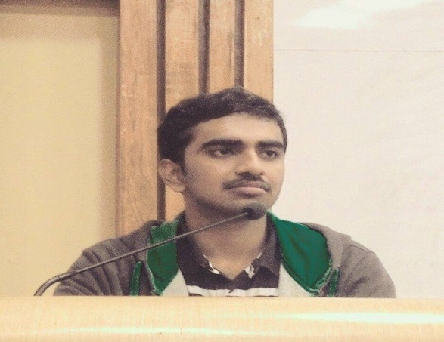

Sai Charan Thirandas

Next Education India pvt. Ltd.

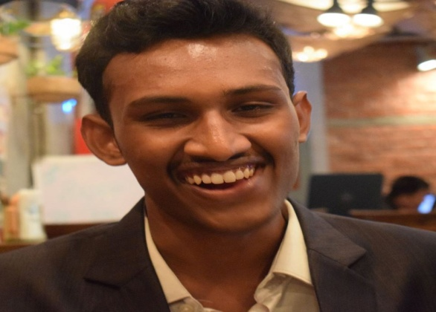

Sree Charan Manamala

Walmart Labs

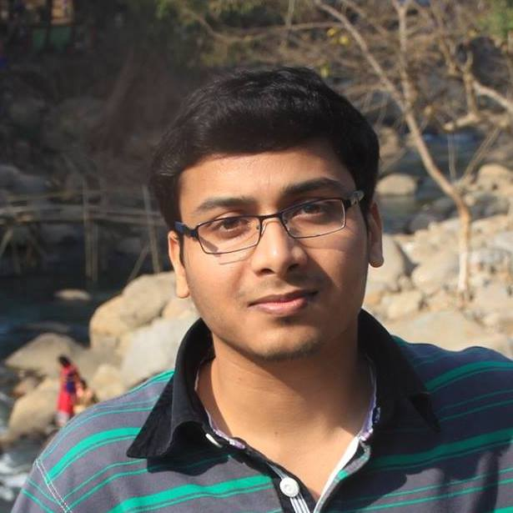

Shantam Raj

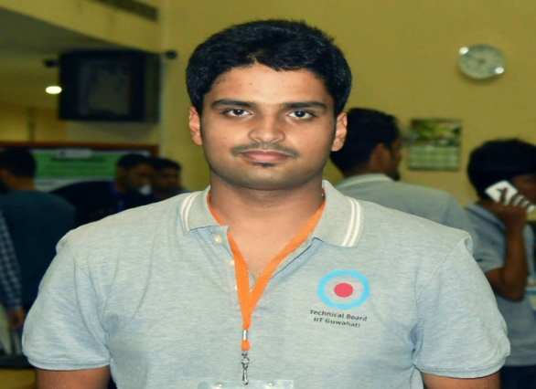

Saumitra Sharma

Adobe India

Core Team Members

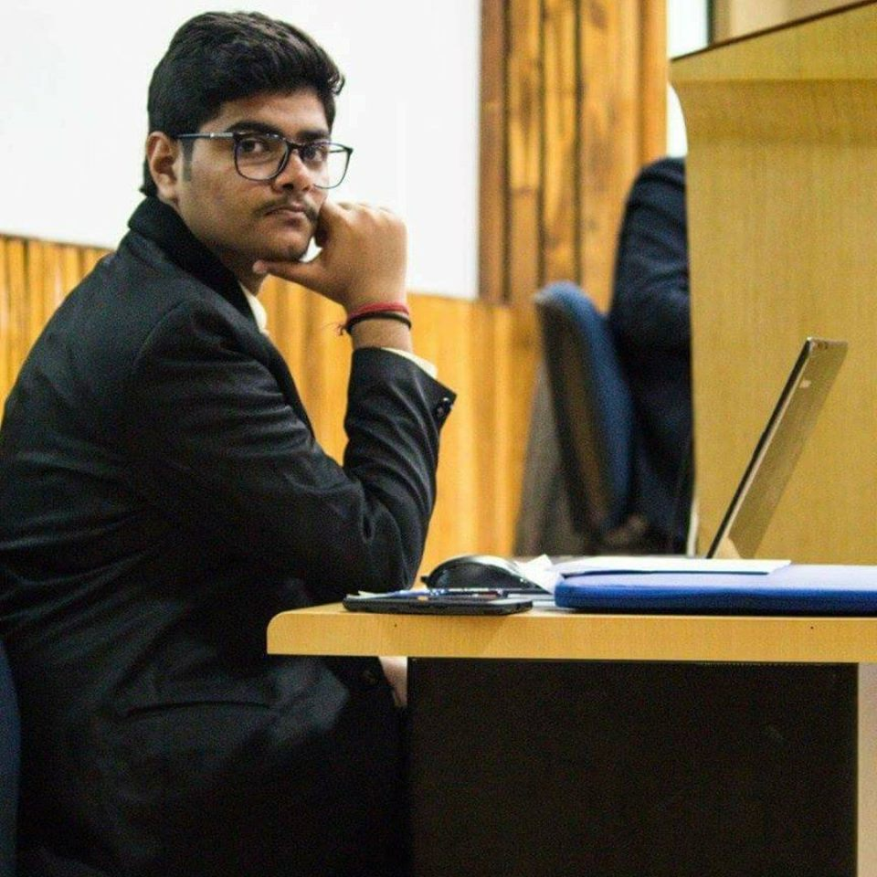

Prateek Manocha

Secretary, Electronics Club Room 202, Kapili Hostel 9711090451

prateek.manocha@iitg.ac.in

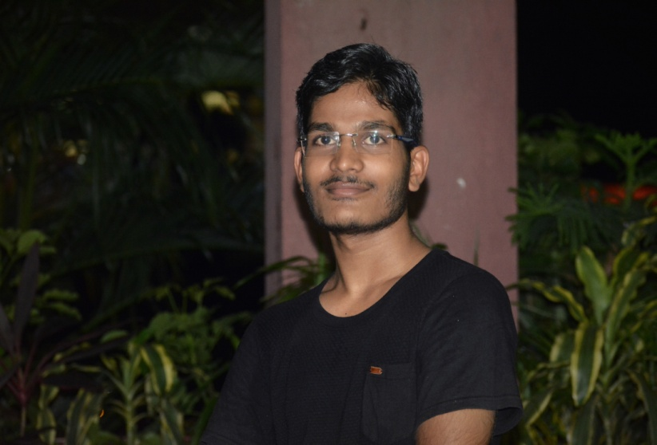

Narendra pal

Events Manager

Room- A231, UMIAM HOSTEL

7004027915 narendra.pal@iitg.ac.in



Balbir Singh

Project Manager

Room A242, umiam hostel

9957993232

balbir.singh@iitg.ac.in

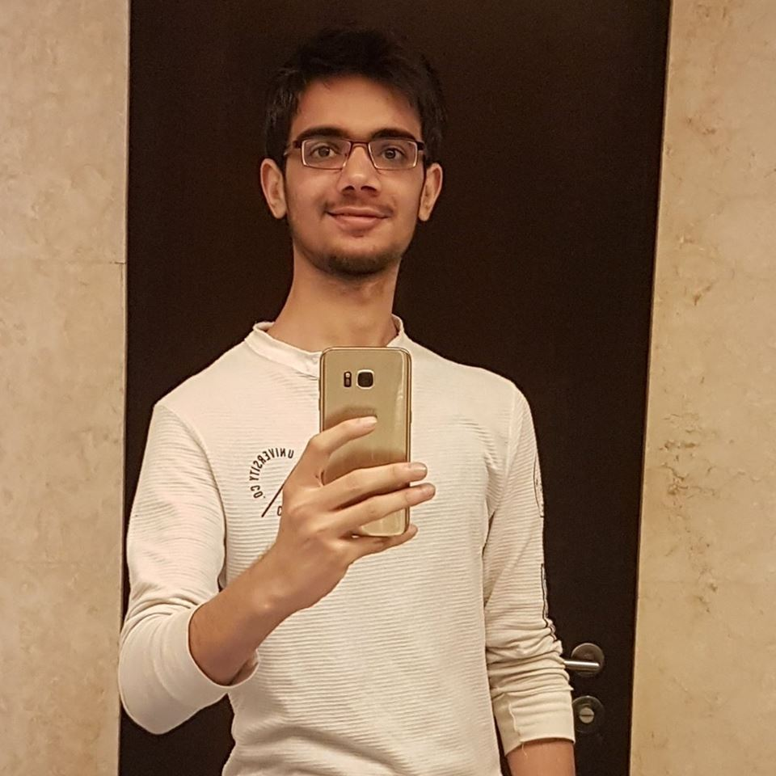

Tarun Yadav

Project Manager

Room- F179, Brahmaputra Hostel  
Contacts : 9957997827  
tarun1998@iitg.ac.in

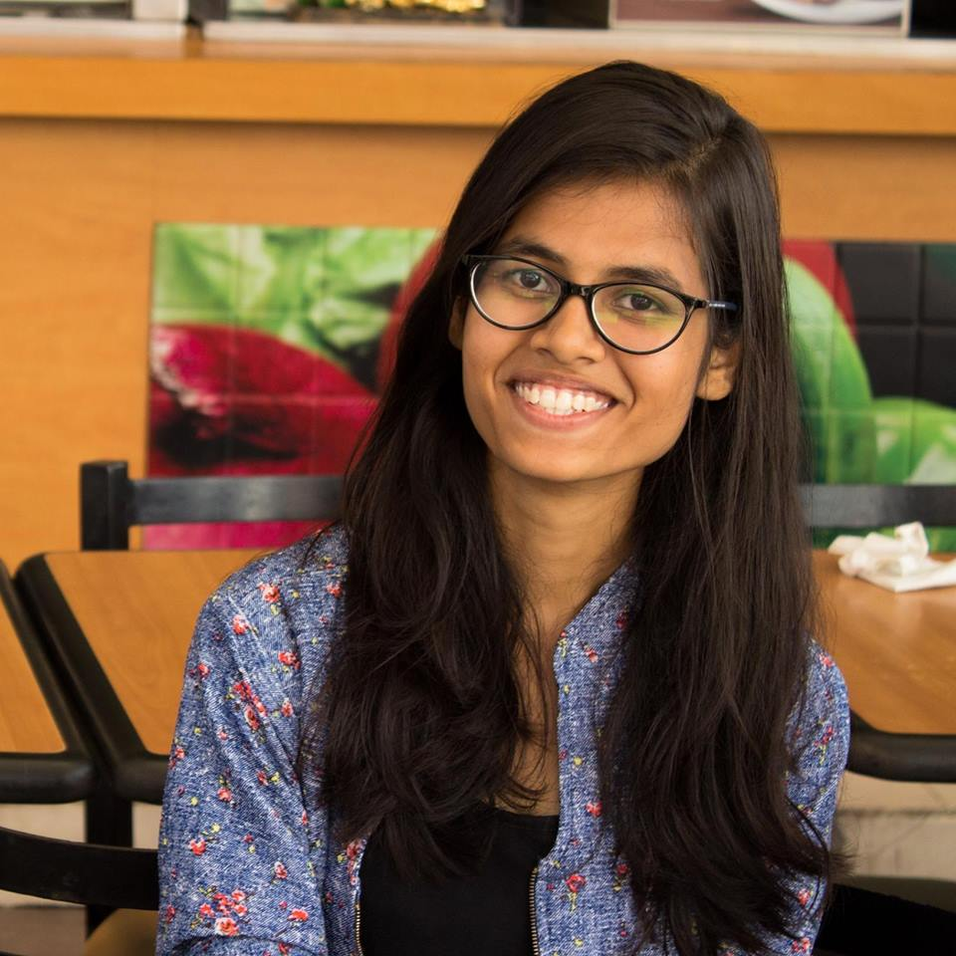

Pallavi Rani

Event manager

Room-CF25, Dhansiri Hostel

Contacts-9957966813

pallavi.rani@iitg.ac.in